**Python Coding Challenge**

**Name: PRIYESHWAR**

**Mail:** [**priyesh2664@gmail.com**](mailto:priyesh2664@gmail.com)

**Loading and Printing rows of the Data**

Read the CSV file into a DataFrame and preview the first few rows using head().

**data=pd.read_csv('annual.csv')**

**data.head()**

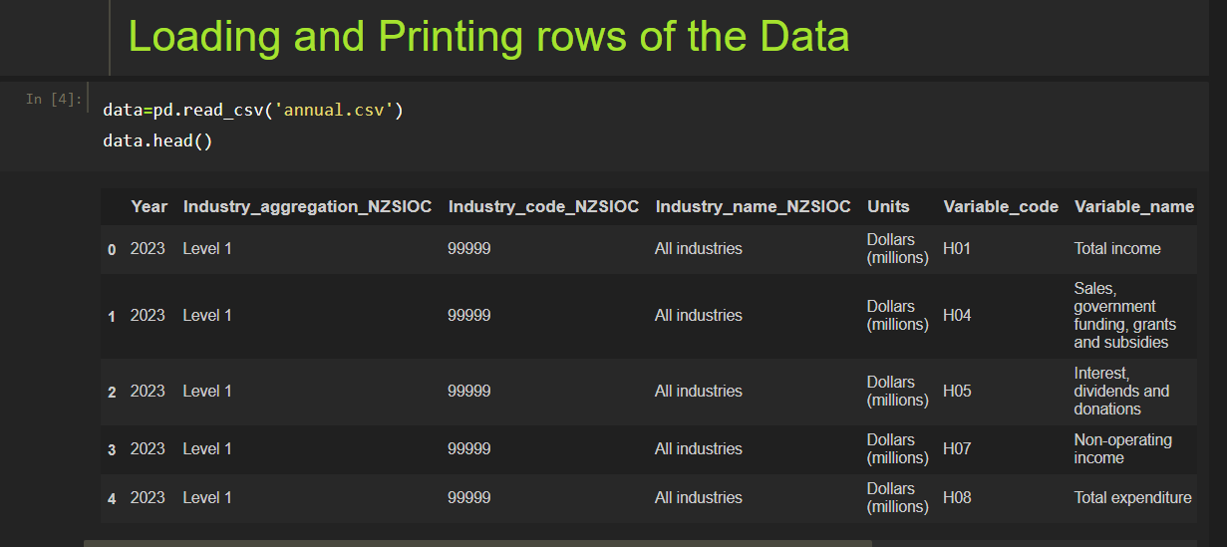

**Summary of Data Frame**

Use info() to display data types and count of non-null values per column.

**data.info()**

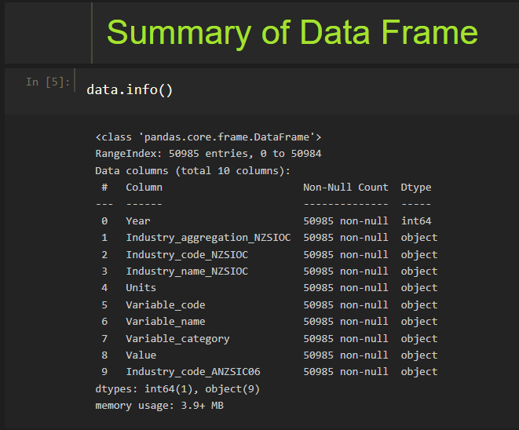

**Descriptive Statistical Measures of a DataFrame**

Generate basic statistics like mean, median, and quartiles with describe().

**data.describe()**

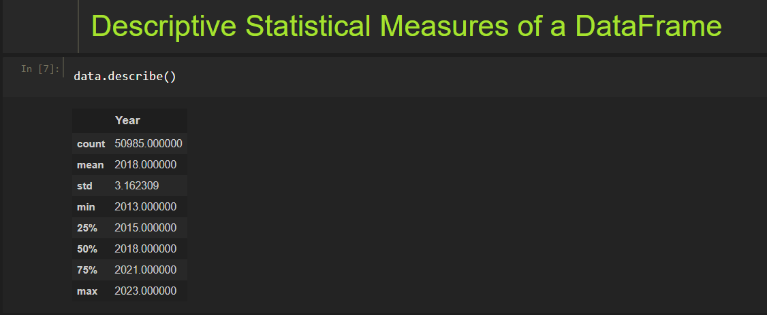

**Finding Null Values**

Check for missing data by summing nulls in each column using isnull().sum().

**data.isnull().sum()**

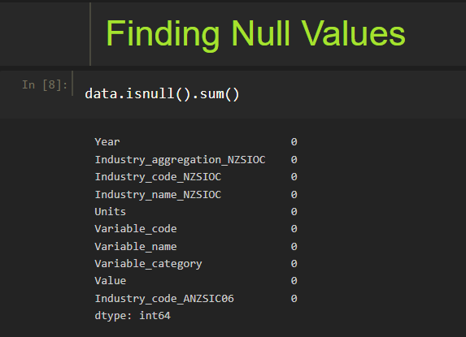

**Missing Data Handing**

Remove rows containing any null values with dropna().

**data.dropna()**

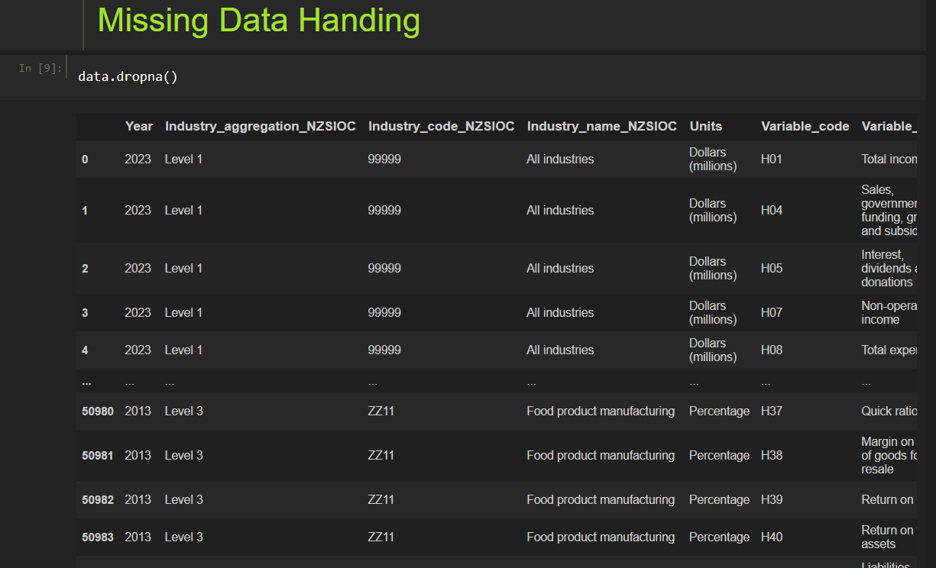

**Sorting DataFrame values**

Sort the DataFrame based on the 'Value' column using sort_values().

**data.sort_values(by='Value')**

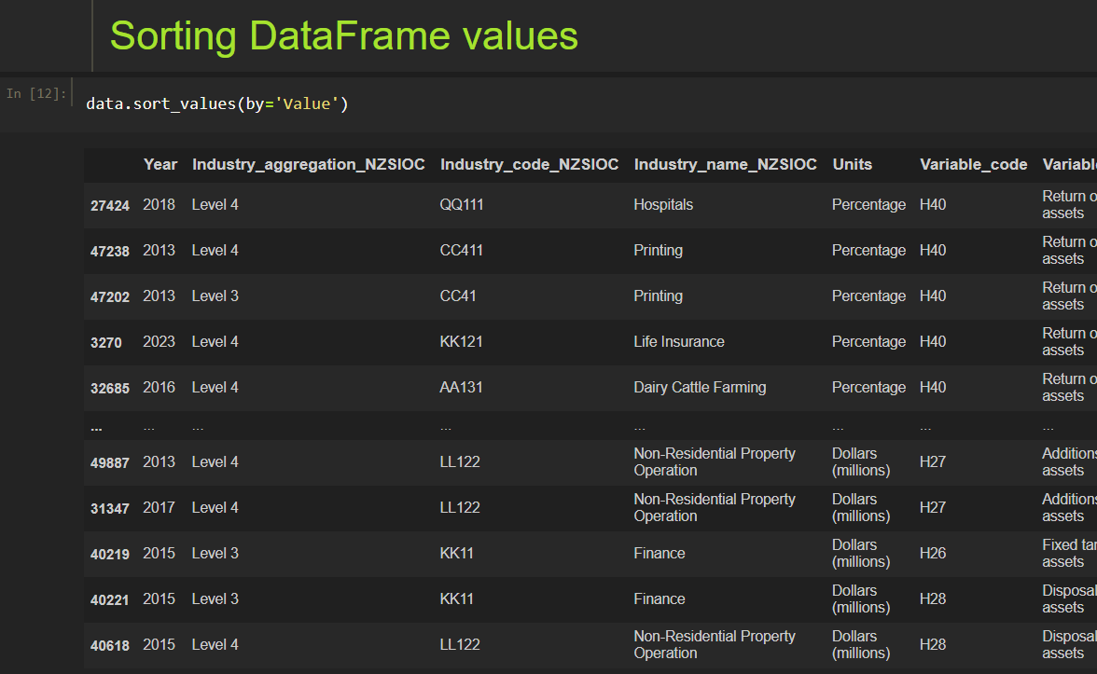

**Merge Data Frames**

Combine sales and products tables on product_id using inner, left, right, and outer joins.

**Inner Join**

**sales = pd.read_csv("sales.csv")**

**products = pd.read_csv("products.csv")**

**inner = pd.merge(sales, products, on="product_id", how="inner")**

**print( inner)**

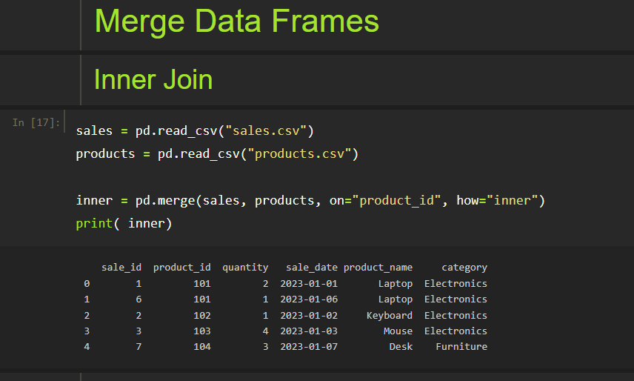

**Left Join**

**left = pd.merge(sales, products, on="product_id", how="left")**

**print(left)**

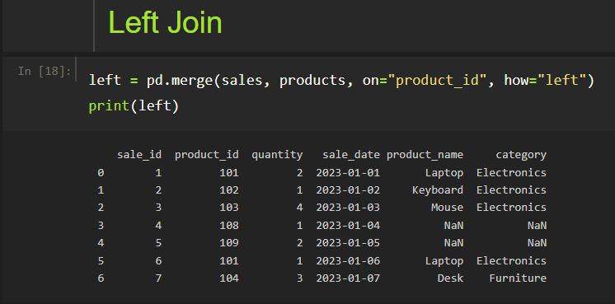

**Right Join**

**right = pd.merge(sales, products, on="product_id", how="right")**

**print(right)**

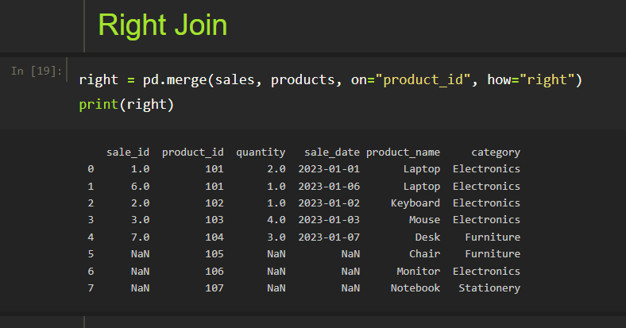

**Outer Join**

**outer = pd.merge(sales, products, on="product_id", how="outer")**

**print( outer)**

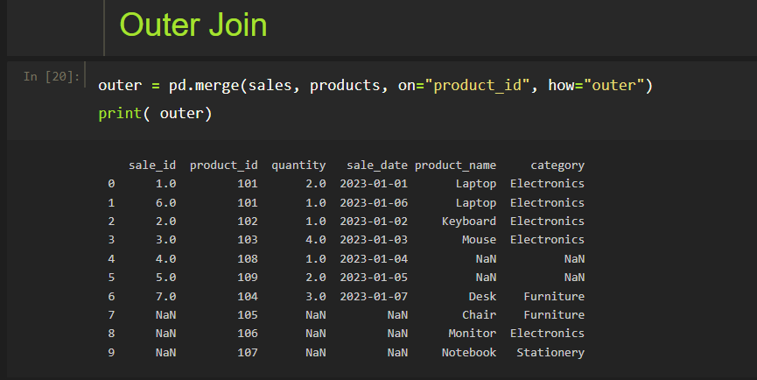

**Visualizing DataFrame**

Plot total quantity sold over time with a line chart using Seaborn’s lineplot().

**import matplotlib.pyplot as plt**

**import seaborn as sns**

**plt.figure(figsize=(10, 6))**

**sns.lineplot(data=outer, x='sale_date', y='quantity', marker='o')**

**plt.title('Total Quantity Sold Over Time')**

**plt.xlabel('Sale Date')**

**plt.ylabel('Quantity Sold')**

**plt.xticks(rotation=45)**

**plt.tight_layout()**

**plt.show()**

